Jyle Darling, William Bernatzki Woellner, Travis Reeve

M093437, 30021175, 30017892

Rapid App Development

AT2 Master Document

Table of Contents

Sprint One 3

Source Control Snapshots 3

Project Management Plan (Sprint one) 4

Software Development Testing Plan 5

Analysis Report 6

Multi-Platform Report 7

Adaptive Design 7

Responsive Design 8

The Choice 8

Demonstration Images 2

Application Testing Documentation 3

Sprint Two 4

Sprint Three 5

Sprint One

# Source Control Snapshots

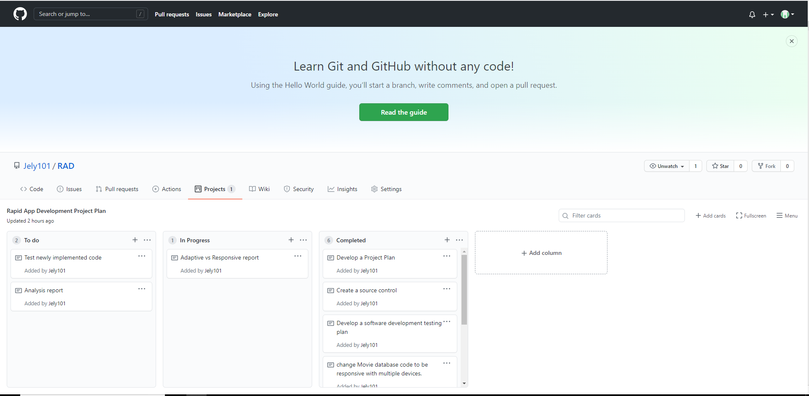

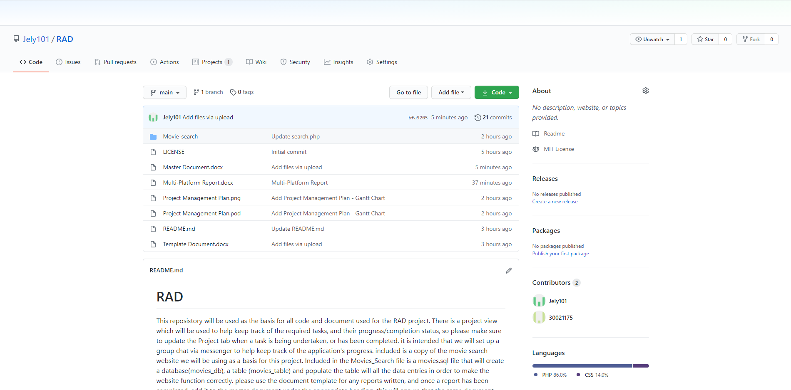

# Project Management Plan (Sprint one)

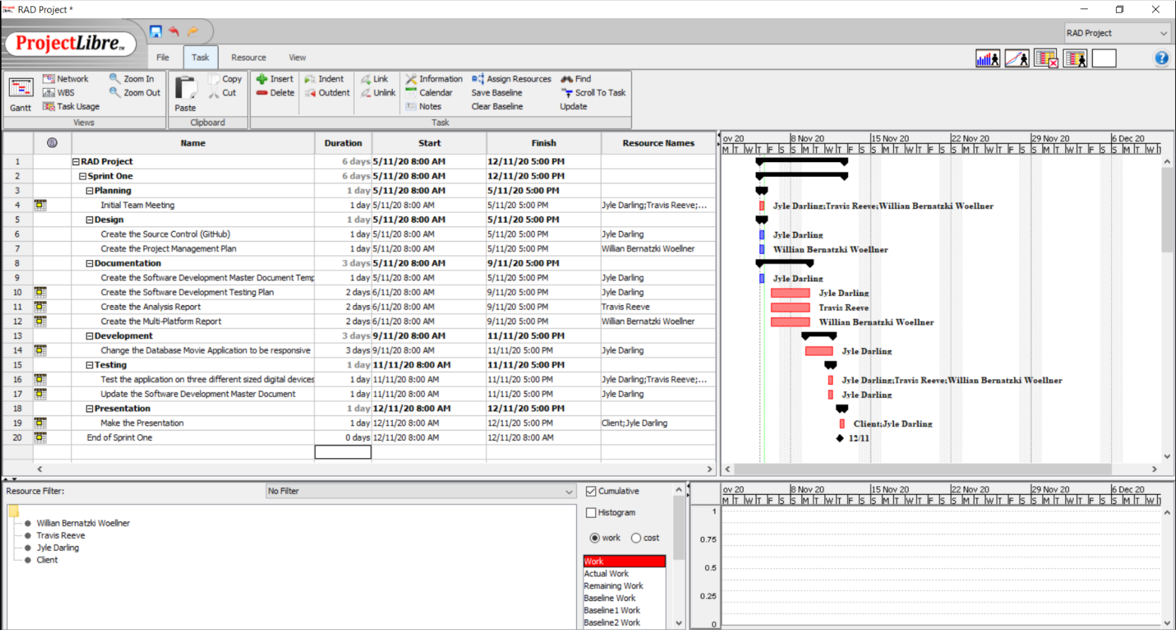

# Software Development Testing Plan

# Analysis Report

# Multi-Platform Report

## Adaptive Design

Adaptive designs consist of multiple renditions of the same design – one for each size, as chosen by the designer or UI developer. Each version of the design is assigned to specific browser widths, called ‘anchor points’. Anchor points tell the browser exactly when to jump to the next layout. (Erickson, 2020)

Instead of using percentages, an adaptive design will utilize exactly one static layout per each anchor point, and adjust to the screen size once that anchor point has been detected. (Erickson, 2020)

Adaptive design can be complex because the designers have to create some different designs on the same page.

Pros and Cons of Adaptive Design. (Charlton, 2014)

|  |  |
| --- | --- |
| **Pros** | **Cons** |
| Super-efficient page loads: Adaptive websites are much better for load time performance and overall user experience. This is because adaptive delivery works by only transferring those assets necessary for the specific device and optimizing images and multimedia content on the fly to suit display resolution and size. | Resource and budget heavy: Adaptive requires a large team of developers and the budget to handle the complexity that comes with choosing to develop and support an adaptive site. |
| No need to scratch your existing website completely: Developers don’t have to go back to the drawing board and re-code the existing website from scratch. | Complexity: Adaptive is a good approach, but creating too many separate designs takes a lot of work and can defeat the purpose of trying to use one set of content on one URL. |

## Responsive Design

In Responsive Design, a website will change its appearance based on the viewport of the browser. Typically developers use the width of the browser as the variable which determines the size of the dynamically changing elements on the page. (Erickson, 2020)

A responsive website is entirely fluid and will adjust and respond to the viewport no matter the size of the browser window (or screen). That is because it uses percentage-based CSS rules to change the style based on the device size. (Erickson, 2020)

Pros and Cons of Adaptive Design. (Jia, 2017)

|  |  |
| --- | --- |
| **Pros** | **Cons** |
| Save cost on responsive web design development: Comparing with the development of websites on PC, iPad, and mobile phones, responsive design is more conducive to saving design and development costs. | Slow down the loading: It will take longer to load for some responsive websites. It’s not a big deal because some unnecessary HTML/CSS will be loaded. |
| User experience friendly: The responsive design can provide users with a friendly web interface, as it can adapt to almost all devices on the screen, including smartphones, tablets, TV, PC monitors, iPhone, and Android phones which contribute to the mobile-friendly website design. | Bad compatibility for the old version of the IE browser: If the site users are mostly using the old version of IE, it is not recommended to do responsive design. |

## The Choice

Analysing the whole scenario of the application, where it needs to be across all major digital devices, the choice of the developer team is the Responsive Design. The main points for this choice are:

* The current website is easier to change to Responsive Design
* There are many templates available to use in a future change. For example Bootstrap
* There is no need for many developers to make the change.
* The development time is less than use Adaptive Design.
* The cost of the project is less because the time is less and there are fewer resources involved in the project.

# Demonstration Images

# Application Testing Documentation

Sprint Two

Sprint Three